## **Task 1**

**Test Case ID**

* **UI-PT.2**

**Scenario**

* **Change Account Information, Check order support**

**Preconditions**

* Browser is open at <https://petstore.octoperf.com/actions/Account.action?editAccountForm=>
* Logged into account John Smith, see A1. Initial Account Details Appendix for more information

**Test Steps**

1. Logged into Account and showing Account Information
2. Changed First name field from “John” to “Johnny”, and password from fake123 to faker123 (see A2 Appendix for screenshot)
3. Click “Save Account Information” button, no confirmation of change message
4. click “Sign Out” button
5. Click “Sign in” button and attempt to sign in with new password, however, not accepting new password
6. Use old password, which is accepted and taken to Store Page
7. Click “My account” button, first name field display “John” and password field blank
8. Click on “?” button for assistance
9. Taken to JPetStore Demo page (see A4 Appednix)
10. Click browser “back” button to go back a page
11. Taken back to Account information and click “Sign Out” button

**Expected Result**

* Changing Account Information and Password met with confirmation pop up display
* Password concealed when typing in new password
* Password changed and able to relog and find new name changes
* Able to find information on support page for various topics and FAQ

**Actual Result**

* When changing First name and password, no confirmation pop up display was provided
* Password is in plain text and not concealed when typing
* Attempt to resign in after changes did not accept new password, able to login using old password
* On when signed back in again, the First Name field had old name
* Support page “?” button served a Demo support page not intended for production environment as reads “the signup page requires you to provide a **user** identifier and password” under the “Signing up” heading

**Summary**

Negative test case fail as there is a high security and business risk because the account cannot change its password or name fields. Attempts to log in after making changes fail, and the user can only gain access using the old password. When changing the password, no confirmation message is displayed, and the new password appears in plain text, rather than being concealed.

Additionally, the support page is difficult to find, as it is labeled with a “?” button instead of “Support.” Even after navigating there, the page shown is a demo page. These issues are high priority, especially regarding account information for billing and other business purposes.

**Appendix**

A1. Initial Account Details

### **User Information**

|  |  |
| --- | --- |
| User ID: | John Smith |
| New password: | fake123 |
| Repeat password: | fake123 |

### **Account Information**

|  |  |
| --- | --- |
| First name: | John |
| Last name: | Smith |
| Email: | [Jsmith@gmail.com](mailto:Jsmith@gmail.com) |
| Phone: | 0430558808 |
| Address 1: | Level 8/207 Kent St |
| Address 2: |  |
| City: | Sydney |
| State: | NSW |
| Zip: | 2000 |
| Country: | Australia |

### **Profile Information**

|  |  |
| --- | --- |
| Language Preference: | English |
| Favourite Category: | FISH |
| Enable MyList | [x] |
| Enable MyBanner | [ ] |

A2. Post Account Details change after Saving Account Information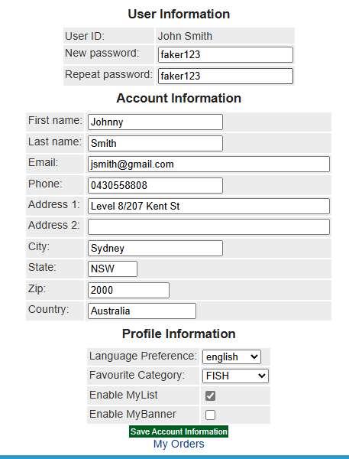

A3. Attempt to sign back in with new password and same username

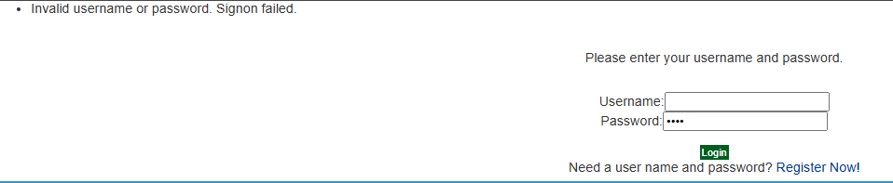

A4. JPetStore Demo page

|  |
| --- |
| **JPetStore Demo** The JPetStore Demo is an online pet store. Like most e-stores, you can browse and search the product catalog, choose items to add to a shopping cart, amend the shopping cart, and order the items in the shopping cart. You can perform many of these actions without registering with or logging into the application. However, before you can order items you must log in (sign in) to the application. In order to sign in, you must have an account with the application, which is created when you register (sign up) with the application.   * [Signing Up](https://petstore.octoperf.com/help.html#SigningUp) * [Signing In](https://petstore.octoperf.com/help.html#SigningIn) * [Working with the Product Catalog](https://petstore.octoperf.com/help.html#Catalog) * [Browsing the Catalog](https://petstore.octoperf.com/help.html#CatalogBrowsing) * [Searching the Catalog](https://petstore.octoperf.com/help.html#CatalogSearching) * [Working with the Shopping Cart](https://petstore.octoperf.com/help.html#ShoppingCart) * [Adding and Removing Items](https://petstore.octoperf.com/help.html#ShoppingCartAdd) * [Updating the Quantity of an Item](https://petstore.octoperf.com/help.html#ShoppingCartUpdate) * [Ordering Items](https://petstore.octoperf.com/help.html#Ordering) * [Reviewing an Order](https://petstore.octoperf.com/help.html#OrderReview) * [Known Issues](https://petstore.octoperf.com/help.html#Issues)  **Signing Up** To sign up, click the Sign-in link at the right end of the banner. Next, click the New User link in the resulting page. Among other information, the signup page requires you to provide a user identifier and password. This information is used to identify your account and must be provided when signing in. **Signing In** You sign in to the application by clicking the Sign-in link at the right end of the banner, filling in the user identifier and password, and clicking the Submit button.  You will also be redirected to the signin page when you try to place an order and you have not signed in. Once you have signed in, you can return to your shopping session by clicking the shopping cart icon at the right end of the banner. **Working with the Product Catalog** This section describes how to browse and search the product catalog. **Browsing the Catalog** The pet store catalog is organized hierarchically as follows: categories, products, items.  You list the pets in a category by clicking on the category name in the left column of the main page, or by clicking on the picture representing the category.  Once you select a category, the pet store will display a list of products within a category. Selecting a product displays a list of items and their prices. Selecting a product item displays a text and visual description of the item and the number of that item in stock. **Searching the Catalog** You search for products by typing the product name in search field in the middle of the banner. **Working with the Shopping Cart****Adding and Removing Items** You add an item to your shopping cart by clicking the Add to Cart button to the right of an item. This action also displays your shopping cart.  You can remove the item by clicking the Remove button to the left of the item.  To continue shopping, you select a product category from the list under the banner. **Updating the Quantity of an Item** You adjust the quantity of an item by typing the quantity in the item's Quantity field in the shopping cart and clicking the Update button.  If the quantity of items requested is greater than that in stock, the In Stock field in the shopping cart will show that the item is backordered. **Ordering Items** You order the items in the shopping cart by selecting the Proceed to Checkout button. The pet store will display a read-only list of the shopping cart contents. To proceed with the checkout, click the Continue button.  If you have not signed in, the application will display the signin page, where you will need to provide your account name and password. Otherwise, the application will display a page requesting payment and shipping information. When you have filled in the required information, you click the Submit button, and the application will display a read-only page containing your billing and shipping address. If you need to change any information, click your browser's Back button and enter the correct information. To complete the order, you click the Continue button. **Reviewing An Order** The final screen contains your order information.  The application can be set up to send email confirmation of orders. This option can only be set when the application is deployed. See the installation instructions for further information.  Copyright www.mybatis.org |